- What is the KEY CONCEPT for section 2-5? ______________________________

_____________________________________________________________________
Main Idea: A catalyst _____________________________________ activation energy.
Choose the best answer to the question.
______2. Activation energy is the energy required to
a. complete a chemical reaction. c. produce a catalyst.
b. start a chemical reaction. d. produce the reactants.
______3. Which of the following can reduce the amount of energy needed for a chemical reaction to take place?
a. reactant b. product c. catalyst d. hydrogen bond
______4. What happens to the speed of a chemical reaction when a catalyst is present?
a. It speeds up. c. It stays the same.
b. It slows down. d. It becomes erratic.

5. Using Figure 4.3 and Figure 5.1, draw an energy diagram below of an exothermic reaction. Be sure to include the following labels: activation energy catalyzed, activation energy un-catalyzed, catalyzed reaction, energy absorbed OR released, normal reaction, products, and reactants.

Energy

Reaction progress

Vocabulary Check - Circle the word or phrase that best completes the sentence.
6. A catalyst can increase / decrease the amount of energy needed to start a chemical reaction.
7. Substrates are to catalysts / enzymes as keys are to locks.
8. Enzymes / substrates are catalysts for chemical reactions in living things.

Main idea: Enzymes _____________ chemical reactions to occur under tightly controlled conditions.
9. Take notes about enzymes by filling in the Main Idea Web below.
How does a substrate affect an enzyme?
How do enzymes affect the
speed of chemical reactions in
the body?

Enzymes
What physical factors affect the action of enzymes?
Where do enzymes act as catalysts?
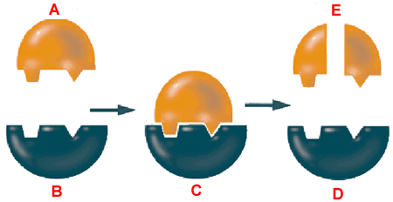
10. Label the following diagram of an enzyme. After labeling give an example

11. Connect to Homeostasis: Organisms need to maintain homeostasis, or stable internal conditions. Why is homeostasis important for the function of enzymes?
______________________________________________________________________________
______________________________________________________________________________
______________________________________________________________________________
12. Go to your online student edition of the text and go to “interactive review” and then on “self-checks”. Take the 2-5 Self-Check Quiz and record your score below. Write out the question AND answer to the ones you missed or the most difficult one. _______ / _______

