**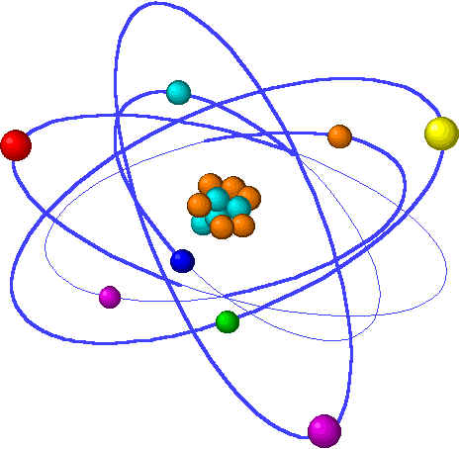3-Dimensional Atomic Model**

**Extra Credit**

**Due: End of 1st quarter**

This extra credit will count as one of your video assessments. It is worth 10 extra credit points.

**Model must:**

1. **Be an atom from the second period of the Periodic Table, must sign up for different atoms (2)**
2. **Have different colors and key for each subatomic particle (2)**
3. **Be sturdy enough to stand or hang alone (2)**
4. **Be accurate with electron energy levels (2)**
5. **Museum quality work (i.e. made to last, not made with perishable materials (2)**

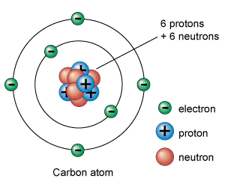

**C:\Program Files\Microsoft Office\Clipart\standard\stddir3\HH01702_.wmfBiology Extra Credit** Name: \_\_\_\_\_\_\_\_\_\_\_\_\_\_\_\_\_\_

Mrs. Breithaupt Hour: \_\_\_\_\_\_\_\_\_\_\_\_\_\_\_\_\_\_

**Directions for Extra Credit T. V. Reports**

1. Watch the program!! I rely on your honesty and personal integrity.
2. Take notes on the parts of the program that YOU find informative, surprising, or interesting. It is **not** necessary to summarize the entire program.
3. Write the report.
   1. Heading (**1 pts**): All reports must include:

1.Name of Program (ex. Nature, Nova, Discovery Health)

2. Title of Program (ex. Killers of the Plains, Medical Incredible)

3. Your name

4. The date the program was shown

5. The hour that you have Biology

* 1. Part A: “What I Learned”: This is the main body of the report. Here you rewrite your notes into clear, concise sentences and paragraphs. It must be a **minimum** of one full (double spaced) typed page. The heading does NOT count towards this one page requirement. Remember, you only have to write what YOU find interesting. Must be ONE PAGE MININUM!!
  2. Part B: “My Opinion”: State whether or not you liked the program **and give your reasons.**  This part of the report must be a **minimum** of one half page (double spaced and typed) Must be HALF PAGE MININUM!!
  3. **All extra credit reports must have all 3 parts in order to even be considered for extra credit points.**

1. The report must follow the rules listed below:

* Typed on ONE SIDE of the paper (no hand-written papers will be accepted!)
* Use standard ( 8 ½ “x11”) white typewriter paper.
* Papers are in twelve-point Times New Roman font, and the entire document is double-spaced.
* Margins: Leave a margin of 1 “ at the left and right side and bottom. Indent the first line of each paragraph (tab over once)
* Number all pages, either in the upper right-hand corner or in the middle at the bottom of the page using “insert – page numbers”
* Be sure your paper observes rules of grammar, punctuation, and spelling.

**1 hour program: Total of 10 points Extra Credit ½ hour program: Total of 6 points**

\*\*\* Extra Credit T.V. reports are limited to 30 points per quarter and *ADDED TO YOUR GRADE AT THE END OF THE QUARTER.*

Note: Extra credit will only be accepted to those who are ***PASSING*** this course by the end of the semester