In your textbook, READ about cellular respiration and glycolysis on pages 228-229. Use each of the terms below only once to complete the passage.
Aerobic anaerobic ATP cellular respiration cytoplasm energy
Glucose glycolysis mitochondria NADH oxygen

Organisms obtain energy in a process called (1) ______________________________________. This process harvests electrons from carbon compounds, such as (2) _________________________, and uses that energy to make (3) ______________________. ATP is used to provide (4) _____________________ for cells to do work. In (5) __________________________, glucose is broken down into pyruvate. Glycolysis is a (n) (6) _______________________ process because it does not require oxygen. Glycolysis takes place in the (7) __________________________. Two molecules of ATP and two molecules of (8) ____________________ are formed for every glucose molecule that is broken down. (9)_____________________ respiration takes place in the (10) ________________________________. It is aerobic because the process requires (11) ________________________________________.
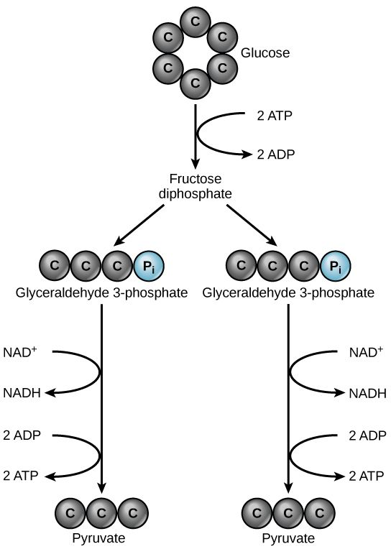
Refer to the diagram of glycolysis (and on page 229). Label the steps in the description to match the diagram.

12. Step _____. Each three-carbon compound is converted into a three carbon pyruvate
Step 1
13. Step _____. A six-carbon compound is broken down into two three-carbon compounds
Step 2
14. Step _____. Phosphate groups from two ATP molecules are transferred to a glucose molecule.
15. Step _____. Two NADH molecules and four ATP molecules are produced.
Step 3
16. Interpret how many total ATP molecules are produced from the glycolysis of one six-carbon glucose. __________________
17. Explain why there is a net gain of only two ATP molecules in the glycolysis of one six-carbon glucose. ____________________
Step 4
______________________________________________________________________________
In your textbook, read about the Krebs cycle, electron transport, and anaerobic respiration on pages 229-232. For each statement below, write true or false. If the statement is false, correct the italicized word.

__________18. The anaerobic pathway that follows glycolysis in the absence of oxygen is fermentation.
__________19. The hydrogen necessary in the electron transport chain comes from the splitting of carbon dioxide molecules.
__________20. Cellular respiration in eukaryotes is slightly more efficient than in prokaryotes.
__________21. The Krebs cycle is sometimes called the TCA or citric acid cycle.
__________22. Fermentation occurs in the mitochondria.
__________23. Skeletal muscle produces lactic acid when the body cannot supply enough oxygen.
__________24. Alcohol fermentation is found in some bacteria and in humans.
__________25. The two pyruvate molecules formed during glycolysis result in two Krebs cycles.
__________26. Electron transport is the first step in the breakdown of glucose.
For questions 27 – 33 (1/2 pt. each), Create a flow chart of cellular respiration using the following words:
Electron transport chain (ETC) 2 ATP Pyruvate Anaerobic Aerobic
Acetyl-CoA Glucose 2 ATP 32 ATP Krebs Cycle
Carbon dioxide (CO₂) oxygen (O₂) water (H₂O)

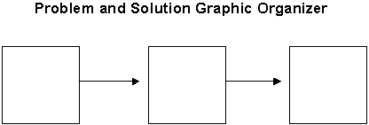
Glycolysis

34. Calculate the total net yield of ATP from one molecule of glucose ___________________________.
35. Based on the diagram and your calculations specify which process produces more energy – the anaerobic pathway or the aerobic pathway. Give evidence for your answer. ________________
______________________________________________________________________________
36. Using the above diagram, infer why after you have been exercising for a while, why do you start breathing hard? ________________________________________________________________
______________________________________________________________________________
______________________________________________________________________________
37. Express the process of cellular respiration as a chemical equation.

