- What is the KEY CONCEPT for section 5-1? ___________________________________________

______________________________________________________________________________

Main Idea: The cell cycle has ___________________ main stages.
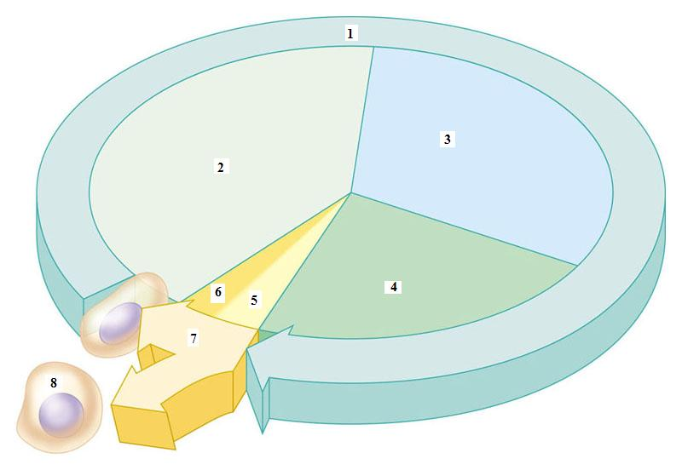
- Label the cell cycle below: cytokinesis, G₁, G₂, interphase, mitosis, S, daughter cell, and cell division

Match the definition to the following terms:

A. S phase (Synthesis) B. Cytokinesis C. G₁ (Gap 1)
D. G₂ (Gap 2) E. Interphase F. Mitosis

______3. Stage in which the cell divides into two daughter cells with identical nuclei
______4. Substage of interphase immediately after a cell divides where cell grows, carries out normal functions and copies its organelles
______5. Substage of interphase in which the cell copies its DNA in preparation for cell division
______6. Stage in which the cell’s nuclear material divides and separates
______7. Main stage in which the cell grows, carries out normal functions, and duplicates its DNA
______8. Substage of interphase where cell goes through additional growth as it prepares for nuclear division
9. The word “cycle” in cell cycle refers to the _________________________________ of growth, DNA duplication, and cell division that occurs in eukaryotic cells.
_____ 10. Cells must pass through a critical checkpoint during which two stages of the cell cycle?
a. M b. S c. G₁ d. G₂

MAIN IDEA: Cells divide at ___________________________ rates.
11. Among different types of cells, the _________ stage of the cell cycle varies most in length.
12. Some scientists name the stage where cells carry out their normal functions but are unlikely to divide. The name they give this stage is _________.
13. Consider the following information: The rate at which a particular type of cell divides is linked to the body’s need for that cell type. Skin cells are typically exposed to more damaging conditions than are liver cells. Skin cells must be replaced more often than liver cells. Therefore, which of these statements is true?
a. Skin cells and liver cells divide at the same rate.
b. Liver cells divide more often than skin cells.
c. Skin cells divide more often than liver cells.
d. Neither skin cells nor liver cells divide.
Main Idea: Cell size is ______________________.
14. Consider the following analogy to explain why cell size is limited. Then, circle the words or phrases in italics that best complete the statements explaining how this analogy relates to cells. Movie theater A holds 1,000 people and has five exits. Movie theater B holds 100 people and has three exits. In an emergency, the people in theater B are able to get out more quickly.
To stay alive, a cell needs materials to move in and out across its membrane. As a cell grows bigger, its volume increases slower / faster than its surface area. At a certain point, the cell’s volume would be too small / too large compared to the area available for materials to move in and out.
15. Which typically increases faster as a cell grows, surface area or volume?
16. Circle the two things that must be coordinated for cells to stay the same size from generation to generation.
a. division b. growth c. repetition d. size
17. The word cytokinesis has the prefix cyto- that refers to a cell and the suffix -kinesis that refers to division or movement. Therefore, cytokinesis is the process where a cell’s cytoplasm ____________.
18. PREDICT – suppose you treat cells with chemicals that block cytokinesis. Describe what you think the cells would look like.

19. Go to your online student edition of the text and go to “interactive review” and then on “self-checks”. Take the 5-1 Self-Check Quiz and record your score below. Write out the most difficult question and answer next to your score.

