Key Concept 1-1: Biology is the study of __________________________________
- Earth is home to an incredible _____________________________________
Biosphere:

Biodiversity:

Species:

Organism:

- “Bio” means ____________________; “-ology” means _______________

- Humans have studied ______________________ throughout __________

Key Concept 1-2: Unifying themes _________________ concepts from many fields of biology.
- _____ organisms _____________ certain characteristics. __________ is the scientific study of ___________ forms of life.

Characteristics Shared by Organisms ( | Details
1.

2.

3.

4.

- An organism is any ____________________________________________
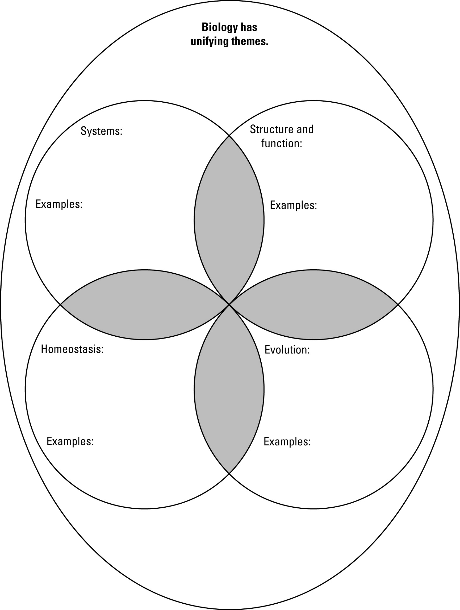
- All levels of ______________ have _________________________ of related parts.
Key Concept 1-3: Science is a way of thinking, ___________________________, and gathering evidence.
- Like all science, biology is a process of _________________________
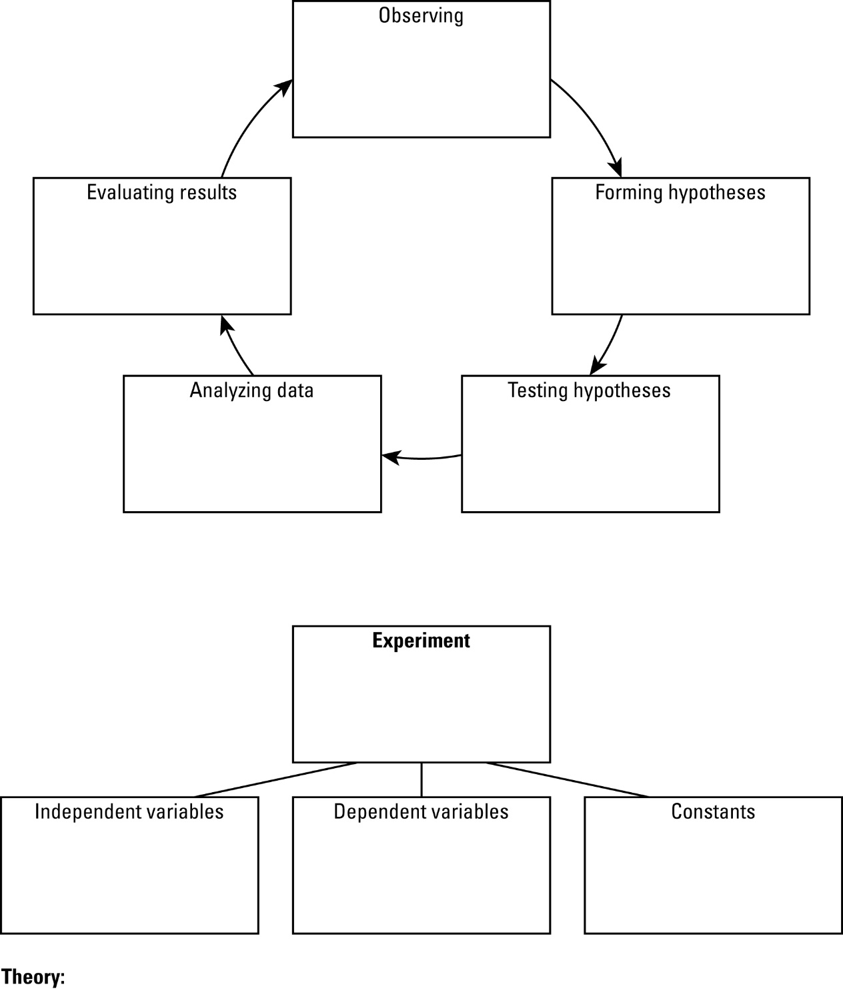
- Biologists use experiments to _______________hypotheses.
- Experiments allow scientists to determine what __________ a phenomenon.

Inference
Control Group
Experimental Group
- Does _________________________ exist?
-Always a chance that some _________________________ factor contributed to result/conclusion of experiment
-Making sure experiment is _____________________ and ______________ is as close as we can get to providing “proof”

- Reliability: experiment must be ___________________________’
  - Others must be able to __________________ experiment with the _____________ results
  - Replicating results is cornerstone of scientific ___________________
  - Experiments that are _____________ to repeat or replicate are _________ reliable
  - Methods/steps should be explicit and _____________________ to make it more reliable.
- Validity: are your findings credible? Does your experiment ____________ what you say it does?
  - Established if experiment meets ___________ requirements of scientific method and experimental design.
  - Did you include a __________________________ group?
  - Did you __________________________________ your sample?
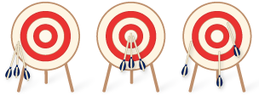
  - Did you keep other factors _____________________________?

Key Concept 1-4: Technology continually _______________________ the way biologists work.
Tool or Technology | Details
Light microscope (LM) | 1.
Scanning electron microscope (SEM) | 2.
Transmission electron microscope (TEM) | 3.
X-ray imaging | 4.
Magnetic resonance imaging (MRI) | 5.
Functional magnetic resonance imaging (fMRI) | 6.
- Complex systems are modeled on computers | 7.
Molecular genetics | 8.
- Imaging technologies provide ___________________________ of life
Key Concept 1-5: Understanding biology can help you make _________________ decisions!
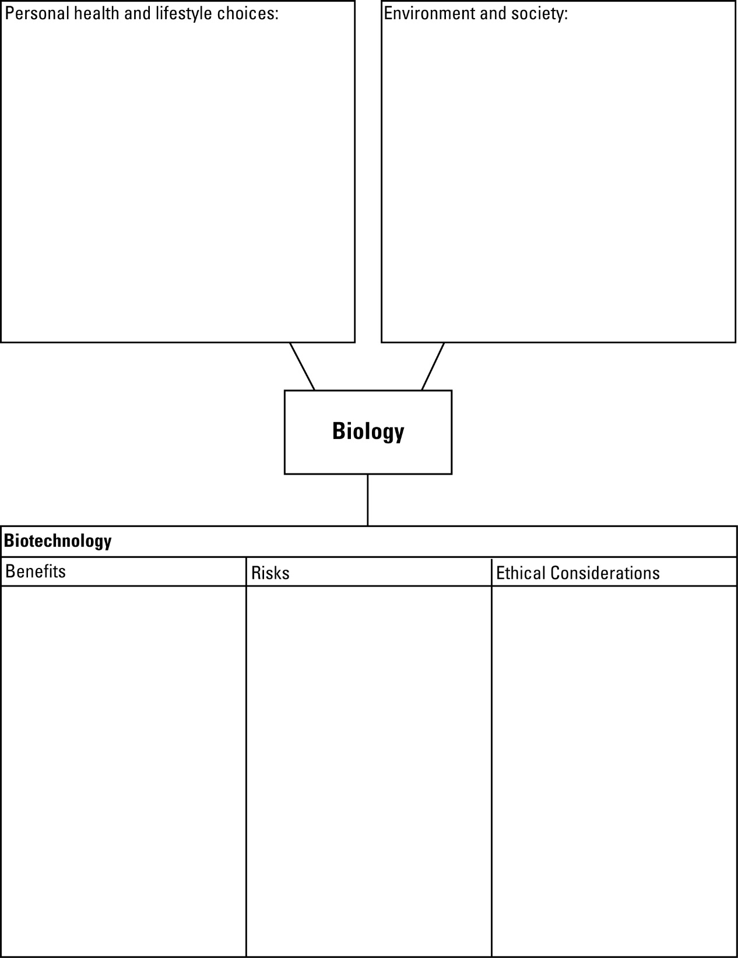
- Your health and the health of the environment _______________ on your knowledge of biology.

- Biology presents many _________________________________ questions.

  - There are still many questions to ____________________ in biology.

- Science vs. Pseudoscience

  - Science

  - Pseudoscience

  - Protoscience

  - Nonscience

