- Why is diffusion over large distances slow and inefficient?
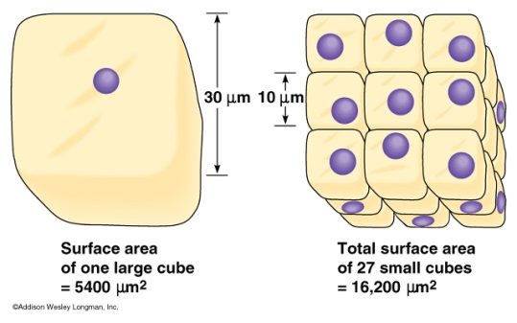
- What limits cell size? (Think about the 3 activities that involved math!)

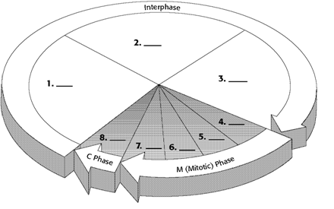
- What are the 3 main phases of the cell cycle? Describe them and label them in the picture.

- What are the 3 sub-phases of interphase? Describe them and label them above.

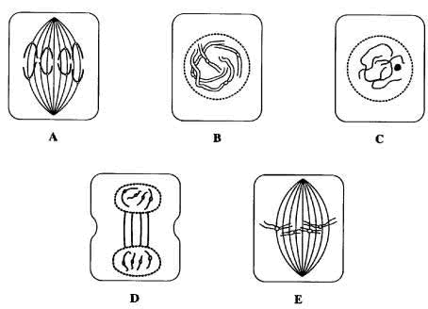
- What are the 4 phases of mitosis? Label and describe them.

- What is the purpose of mitosis? What are the products of mitosis?

- What is the function of spindle fibers? What would happen without them?
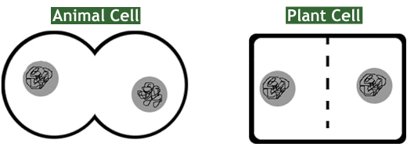
- Describe cytokinesis in animal cells and in plant cells. Identify which is which and label differences.

- Tell the difference between chromatin, chromosome, and chromatid. Draw if needed.

- Where are the cell cycle checkpoints? Describe the purpose of each. Label those on the diagram above.

- What is apoptosis? Give examples.

- What are the two types of stem cells?
- What is the stem cell controversy? What are pros and cons?

- What must be damaged for cancer to form?
- What is the definition of cancer?

- What are role do cyclins and CDK’s have in the cell cycle?

- What is a carcinogen? Give examples.

