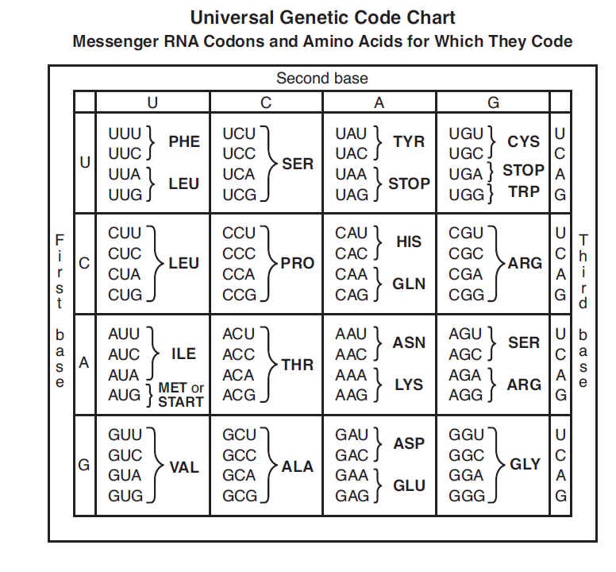
http://secretsofmoms.com/codon-chart-worksheet/

