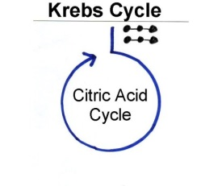**Problem**: How is energy transferred and transformed in living systems?

**Background:**  Living organisms display the property of **metabolism**, which is a general term to describe the processes carried out to acquire and use energy. We know that people need to eat, and in our foods are various kinds of nutrients that our cells use. One large group of nutrients in our foods is carbohydrates, which supply our cells with glucose (C6H12O6). So the question is: How does the food we chew and swallow fuel our cells?. [**NGSS**: HS-LS1-7]

***Directions:*** Use *Model 2 – Krebs Cycle* to answer the following questions.

1. According to Model 2, what happens to pyruvic acid (pyruvate) during the Krebs cycle? __________

_____________________________________________________________________________

_____________________________________________________________________________

2. Where does the change identified in the previous question occur? ___________________________

3. Note the number of atoms of carbon in pyruvic acid and explain why three molecules of carbon

dioxide are produced. ___________________________________________________________

_____________________________________________________________________________

_____________________________________________________________________________

4. Considering that glycolysis produces two pyruvic acid molecules per glucose molecule, how many total CO2 molecules will be produced from the complete breakdown of each glucose molecule?

Show a mathematical equation to support your answer. ________________________________

_____________________________________________________________________________

5. What two hydrogen-carrying molecules are formed during the Krebs cycle? ___________________

6. Fill out the chart by looking back at the entire process of glycolysis and the Krebs cycle to list the total number of ATPs and hydrogen-carrying molecules produced.

|  |  |  |  |
| --- | --- | --- | --- |
| **Process** | **ATP** | **NADH** | **FADH2** |
| Glycolysis |  |  |  |
| Krebs cycle  (1st pyruvic acid) |  |  |  |
| Krebs cycle  (2nd pyruvic acid) |  |  |  |



**Putting it all together**

1. With your partner, choose an appropriate graphic organizer to visualize the process and products of the Krebs cycle.