Measuring Length Name____________________
In Science, you will be using measured numbers in lab, exercises, and on tests and quizzes. The number of digits reported for a numerical quantity conveys the quality of the measurement or accuracy of the instrument used. When recording data or calculating numerical values, the precision of these values, which is represented by the number of digits, is vital information. In science courses, you will use a meaningful number of digits in reporting your results. Laboratory measuring instruments have their limits, just as your senses have their limits. One of your tasks, in addition to learning how to use various measuring instruments properly, will be to correctly determine the precision of the measuring devices that you use in the lab. Distances are normally measured with a ruler. The limit of accuracy of a ruler is indicated by how "precisely" you can read the length on that ruler’s scale—that is, how well you can estimate between the marks.
Here is the key for determining the precision of most measuring devices: You can usually estimate to only one decimal place beyond the closest marks on any measuring device!! On your metric ruler, the closest marks are 0.1 cm apart, so you can estimate to the hundredths place, 0.01 cm. However, when looking at a metric ruler in the real world, the smallest marks (i.e. millimeter marks, mm) are so close that it is all we can do just to determine that the measurement is either exact or about half way between.
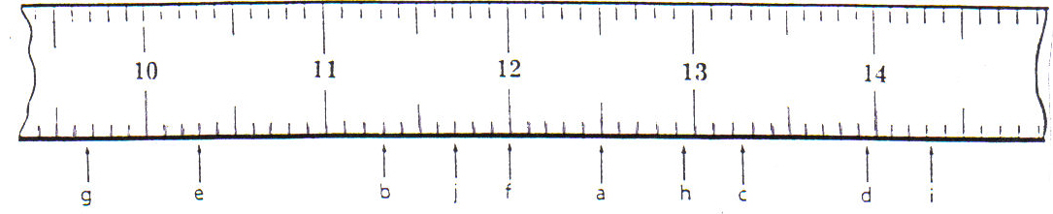
Use the ruler segment above to practice recording length measurements to the correct decimal place. Remember, when recording in cm you should include two places past the decimal. With mm, record only one place past the decimal.
Letter | cm | mm
A
B
C
D
E
F
G
H
I

