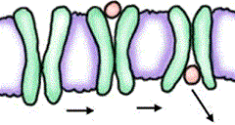**Problem:** How do substances move in and out of cells?

**Background:** Advertisements for sports drinks, such as Gatorade®, PowerAde®, and Vitaminwater™, etc. seem to be everywhere. All of these drinks are supposed to help your body recover and replenish lost electrolytes, fluids, and vitamins after exercise. But how do the essential molecules contained in these drinks get into your cells quickly to help you recover after exercise?

**Directions:** Use *Model 1*- Simple Diffusion to answer the following questions

1. How many different types of molecules are shown in Model 1? ____________________________

2 Count and record the number of triangles and circles found on each side of the membrane.

|  |  |  |
| --- | --- | --- |
| **Shape** | **Left side** | **Right side** |
| Triangles |  |  |
| Circles |  |  |

3. Which shape is larger? _____________________________

4. Describe the direction of the movement of the molecules in Model 1? _____________________

___________________________________________________________________________

5. Which molecules are able to pass through the semi-permeable membrane? _________________

Justify your answer. __________________________________________________________

___________________________________________________________________________

6. If you left this “system” for an extended period of time and then viewed it again, would you expect to find any changes in the concentrations of the molecules on either side of the

membrane? Justify your answer.________________________________________________

___________________________________________________________________________

___________________________________________________________________________

___________________________________________________________________________

**Directions:** Use *Model 2*: *The Selectively Permeable Membrane* to answer the following questions



7. What two major types of biological molecules compose the majority of the cell membrane in

Model 2? ____________________________ and __________________________________

8. How many different protein molecules are found in Model 2? _____________________________

What types are they? _________________________________________________________

9. What is the difference between the position of the surface proteins and the membrane-spanning

proteins? __________________________________________________________________

________________________________________________________________________

________________________________________________________________________

10. When a carbohydrate chain is attached to a *protein*, what is the structure called? ____________

11. When a carbohydrate is attached to a *phospholipid*, what is the structure called? ____________

12. What types of molecules are shown moving across the membrane? _______________________

________________________________________________________________________

13. Where exactly in the membrane do these molecules pass through? _______________________

________________________________________________________________________

14. How does the concentration of the small molecules inside the cell compare to that outside the

cell? ______________________________________________________________________

________________________________________________________________________

15. Because particles move randomly, molecules tend to move across the membrane in both directions. Does the model indicate that the molecules are moving in equal amounts in both direc­tions? **Justify** your answer using complete sentences.

___________________________________________________________________________

___________________________________________________________________________

___________________________________________________________________________

16. Now that you’ve completed this activity, go back to the original problem, and answer it as a

group. ***PROBLEM***: **How do substances move in and out of cells?**

________________________________________________________________________

________________________________________________________________________

________________________________________________________________________

________________________________________________________________________

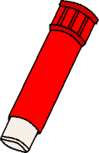 Putting it all together

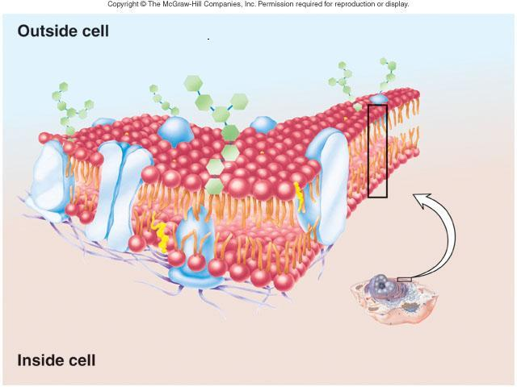

***Directions*:** COLOR the diagram and label the following on the above picture

|  |  |  |
| --- | --- | --- |
| **Structure** | **Color** | **Function** |
| Plasma membrane |  |  |
| Hydrophilic head |  |  |
| Hydrophobic tails |  |  |
| Cholesterol |  |  |
| Transport protein |  |  |
| Carbohydrate |  |  |
| Marker protein |  |  |
| Receptor protein |  |  |