Skills Worksheet
Test Prep Pretest-Cellular Energy
In the space provided, write the letter of the term or phrase that best completes each statement or best answers each question.
1. Which of the following correctly sequences the flow of energy through an ecosystem?
a. bacteria, water, algae, fish c. sun, grass, rabbit, fox
b. bacteria, sun, grass, deer d. algae, sun, small fish, shark
2. What is the purpose of cellular respiration?
a. to store carbohydrates
b. to produce energy from carbohydrates
c. to produce oxygen
d. to store oxygen in water
3. What is the main way cells get energy from ATP?
a. by using water to release energy from the molecule
b. by breaking the single phosphate bond in the molecule
c. by breaking one of the two phosphate bonds in the molecule
d. by breaking one of the three phosphate bonds in the molecule
4. ATP synthase gets the energy it needs to make ATP directly from
a. hydrogen ions diffusing through the channel in the protein.
b. hydrogen ions it pumps out of the cell, across the cell membrane.
c. electrons in pigments that have absorbed sunlight.
d. electrons that have bonded to carbohydrate molecules.
5. Electron transport chains are a series of molecules
a. on the inner membrane of some organelles that accept excited electrons and use their energy to move H⁺ ions across the membrane.
b. on the outer membrane of some organelles that accept H⁺ ions and use their energy to move electrons across the membrane.
c. on the inside of some cell membranes that accept H⁺ ions and use their energy to move protons out of the cell.
d. on the outside of some cell membranes that accept excited elections and use their energy to move H⁺ ions into the cell.
6. How do plants get energy from light?
a. Light excites hydrogen ions in the outer membrane of chloroplasts.
b. Light excites electrons in a special chlorophyll molecule.
c. Light excites ATP synthase in the membrane of plant cells.
d. Light excites electron carriers in carotenoids.
7. Which do plants need to complete making sugars via photosynthesis?
a. glucose b. oxygen c. alcohol d. carbon dioxide
Test Prep Pretest continued
8. Which of the following environmental factors does not directly influence the rate of photosynthesis?
a. light intensity c. carbon dioxide concentration
b. oxygen concentration d. temperature
9. In glycolysis,
a. glucose is produced.
b. aerobic processes produce energy-storing sugars.
c. one molecule of ATP and one molecule of NADPH are produced.
d. one molecule of pyruvate and four molecules of ATP are produced.
10. Which of these occurs during the Calvin cycle?
a. An animal cell produces a net total of two molecules of ATP.
b. An animal cell produces up to a net total of 36 molecules of ATP.
c. A plant cell produces one energy-storing sugar molecule.
d. A plant cell produces up to 36 energy-storing sugar molecules.
11. Which of these are end products of the Krebs cycle?
a. ATP, NADH, and FADH₂ c. ATP and pyruvate
b. ATP and oxygen d. ATP and energy-storing starch
12. Which of the following is never part of cellular respiration?
a. an electron transport chain c. the Krebs cycle
b. glycolysis d. the Calvin cycle
13. The most efficient form of cellular respiration requires
a. carbon dioxide as a source for making energy-storing molecules.
b. water as a source of excited electrons in electron transport chains.
c. oxygen as an electron acceptor so electron carriers can be recycled.
d. lactic acid as an electron acceptor so electron carriers can be recycled.
Question 14 refers to the figure below, which shows a chloroplast.
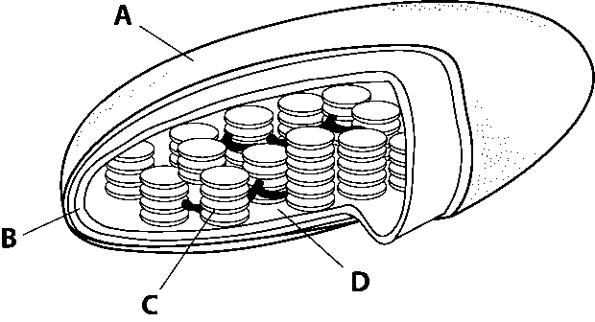
14. The reactions of the electron transport chains occur in the structure labeled
a. A. b. B. c. C. d. D.
Test Prep Pretest continued
15. Which substances are involved in two different types of fermentation?
a. ethanol and lactic acid c. glucose and oxygen
b. glucose and ethanol d. lactic acid and glucose
16. What is the net maximum number of ATP molecules that can be produced through cellular respiration?
a. 41 c. 34
b. 38 d. 2
Complete each statement by writing the correct term or phrase in the space provided.
17. During photosynthesis, organisms called ______________________ convert ______________________ energy to ______________________ energy.
18. Cells gradually release energy in chemical reactions that are assisted by catalysts called ______________________.
19. Light-absorbing ______________________ are located in the membranes of flat sacs called ______________________, which are stacked inside ______________________.
20. During the light reactions of photosynthesis, one ______________________ ______________________ ______________________ uses energy from excited electrons to make ____________ the other uses energy from excited electrons to make ____________. These molecules are used in the ______________________ ______________________ of photosynthesis.
21. Some organisms use the process of fermentation to resupply electron acceptors for ______________________, so that ATP can be produced in the absence of ______________________.
22. Aerobic respiration occurs in the ______________________ of eukaryotic cells.
Test Prep Pretest continued
Read each question, and write your answer in the space provided.
23. Explain how organisms participate in Earth’s carbon cycle through metabolic processes.

24. Explain how the metabolism of organisms that are not autotrophic differs from that of autotrophs.

25. What is ATP and why is it considered a form of “energy currency” for a cell?

26. Briefly explain how ATP is produced by electron transport chains.

